

**QGIS Lab Series**

**GST 102: Spatial Analysis**

**Lab 4: Vector Data Analysis - Overlay Techniques**

**Objective – Understanding Basic Vector Analysis Using Overlays**

**Document Version:** **2014-06-20 (Final)**

**Author:**

Kurt Menke, GISP



**Contents**

1 Introduction 2

2 Objective: Understanding Basic Vector Analysis Using Overlays 2

3 How Best to Use Video Walk Through with this Lab 2

Task 1 Clip 3

Task 2 Intersection 5

Task 3 Union 8

Task 4 Join Attributes by Location 11

5 Conclusion 14

6 Discussion Questions 14

7 Challenge Assignment 14

1. Introduction

In this lab, you will be learn about several powerful vector analysis tools. The tools are all considered overlay tools, since they produce outputs defined by how features overlap one another. You will be working with several datasets covering the Sierra National Forest in California.

This lab includes the following tasks:

Task 1 Clip

Task 2 Intersection

Task 3 Union

Task 4 Join Attributes by location

1. Objective: Understanding Basic Vector Analysis Using Overlays

The objective of this lab is for the student to understand basic use of vector overlays in a geospatial analysis.

**Vector Overlays** – A set of tools, which work on the spatial relationships between two input datasets. The output is a new dataset derived from those spatial relationships.

**Clip** – Outputs the features of the input dataset that are within the features of the clip dataset. It is commonly used to cut datasets to the study area boundary.

**Intersection** – Takes two polygon datasets and outputs the areas common to both.

**Union** – A topological overlay of two polygon datasets, the output preserves the features that fall within the spatial extent of either input dataset.

**Join Attributes by Location** – Also known as a spatial join, this operation appends the attribute columns of one data set to another, based on the geographic intersection of the two datasets.

1. How Best to Use Video Walk Through with this Lab

To aid in your completion of this lab, each lab task has an associated video that demonstrates how to complete the task. The intent of these videos is to help you move forward if you become stuck on a step in a task, or you wish to visually see every step required to complete the tasks.

We recommend that you do not watch the videos before you attempt the tasks. The reasoning for this is that while you are learning the software and searching for buttons, menus, etc…, you will better remember where these items are and, perhaps, discover other features along the way. With that being said, please use the videos in the way that will best facilitate your learning and successful completion of this lab.

1. Clip

This lab focuses on the Sierra National Forest in California. Datasets include: the National Forest boundary, Ranger Districts, and habitat data for both spotted owl and Southwest willow flycatcher. In this first task, you will be clipping data to the study area. The spotted owl is listed as Threatened and the southwest willow flycatcher is listed as endangered by the U.S. Fish and Wildlife Service.

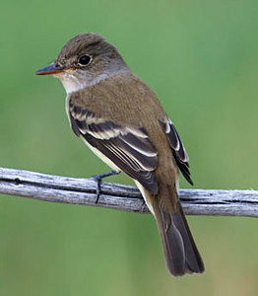 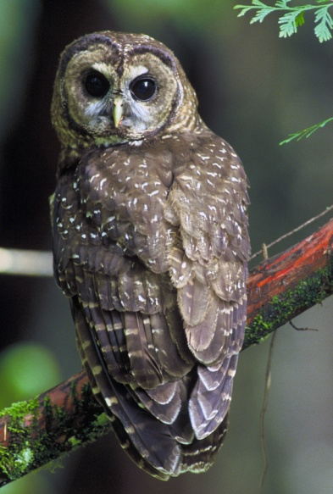

Southwest Willow Flycatcher Spotted Owl

1. The data for this lab is located on the lab machine at: *C:\GST102\Lab 4\Data.*
2. **Open QGIS Desktop 2.2.0**
3. **Add** both the **Sierra_Natl_Forest.shp** and **CA_Spotted_Owl_HmRngCore.shp** shapefiles to **QGIS Desktop.** **Move** the **Sierra National Forest layer** **below** the **spotted owl layer**.

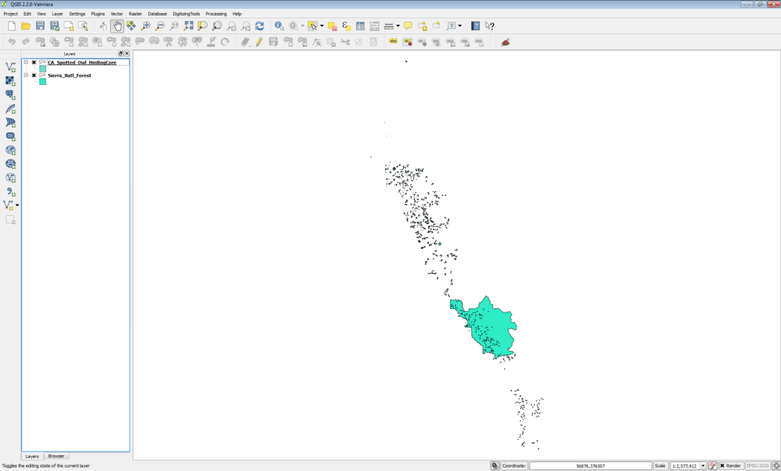

**Figure 1: Sierra National Forest and Spotted Owl data in QGIS**

In this case, you are only interested in the data covering the Sierra National Forest. Notice that the spotted owl data covers far more territory than the forest. Therefore, you will clip the spotted owl data to the forest boundary. **Clip** will create a new shapefile consisting of the spotted owl polygons within the forest boundary. It is standard protocol to clip datasets to the extent of the study area. This reduces data to only that which needs to be processed, and makes processing and rendering faster.

1. Before conducting a spatial analysis, you need to ensure that all the involved layers are in the same coordinate reference system. **Open** the **Layer Properties** for each layer, and **identify** the **coordinate reference system**.

**Question # 1** **– Are both layers in the same coordinate reference system? What is the coordinate reference system of each layer?**

1. From the menu bar choose **Vector 🡪 Geoprocessing Tools 🡪 Clip**
   1. Input vector layer = **CA_Spotted_Owl_HmRngCore**
   2. Clip layer = **Sierra_Natl_Forest**
   3. Output shapefile = Lab 4/Data/MyData/**Sierra_Spotted_owl.shp**
   4. Check **Add result to canvas**
   5. **Click OK**
   6. **Click Close**
2. The new layer will appear in the Table of Contents. Remove the original **CA_Spotted_Owl_HmRngCore** layer. It was an intermediate dataset.
3. **Right click** on the **Sierra_Natl_Forest** layer and choose **Zoom to layer extent.** Your map should now resemble **Figure 2**. Unlike **selecting by location** and **exporting** the selected set to a new layer, the **Clip** operation actually cuts spotted owl polygons at the forest boundary where they crossed the forest boundary.

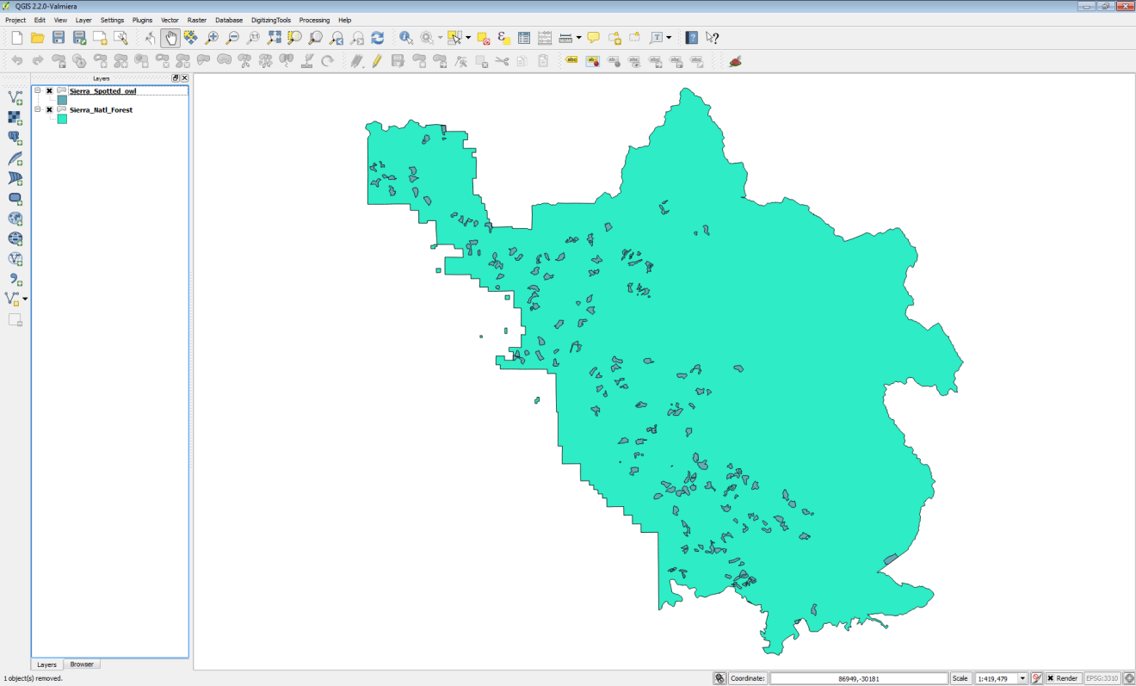

**Figure 2: Spotted Owl Data Clipped to the Forest Boundary**

1. **Save** the project as **Lab 4.qgs**
2. Intersection

You will now include the southwest willow flycatcher habitat data in the analysis.

1. **Open QGIS Desktop 2.2.0** and open Lab 4/Data/Lab 4.qgs if it is not already.
2. **Add** S**ierra_WillowFlycatcher** shapefile to QGIS Desktop. This data set falls completely within the forest boundary so there is no need to clip it.
3. Spend a few minutes **styling** your **data**.
   1. Give the National forest a light green color
   2. Give the spotted owl habitat an orange fill
   3. Give the Southwest willow flycatcher habitat a red fill and outline.
4. Your map should now resemble **Figure 3**.
5. Usie the **Zoom in** tool  **to drag a box** and zoom in to the area outlined in black in **Figure 3**.

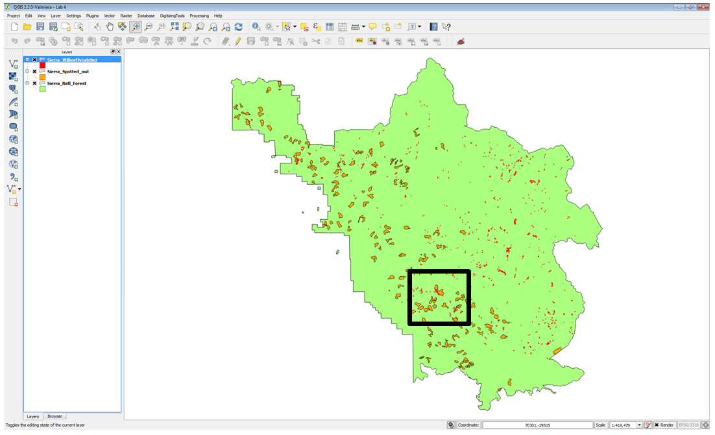

**Figure 3: All Three Layers in QGIS**

You will notice that in this area, there is some overlap between the Southwest willow flycatcher and spotted owl habitat (**Figure 4**). Since these are both sensitive species, areas of habitat overlap will be important areas to protect. You could certainly conduct a spatial query to select Southwest willow flycatcher polygons that overlap spotted owl polygons. However, here you will see the value of using the **Intersect** tool to identify these overlapping areas.

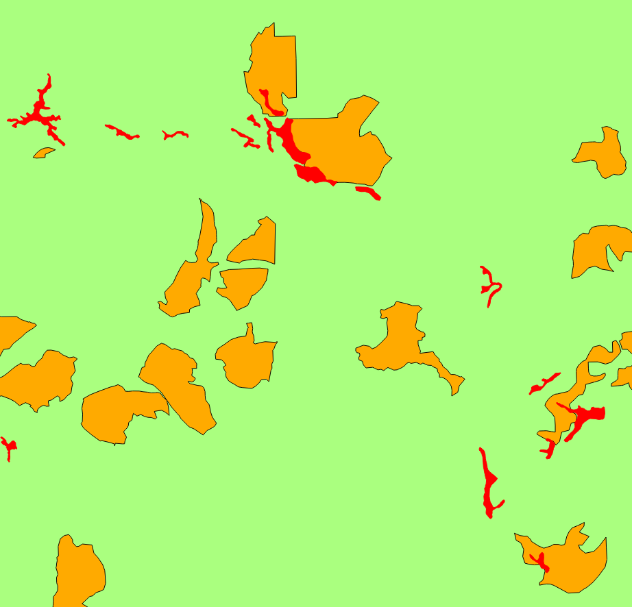

**Figure 4: Overlap Areas**

1. From the menu bar choose **Vector 🡪 Geoprocessing Tools 🡪 Intersect**. Fill out the form as in **Figure 5** below.

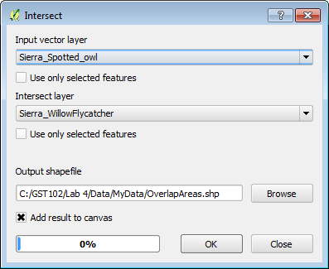

**Figure 5: Intersect Tool**

1. When finished **Click Ok** and then **click Close**.
2. **Style** the **OverlapAreas** with a bright yellow **Fill** and **Border**. Your map should now resemble **Figure 6**.

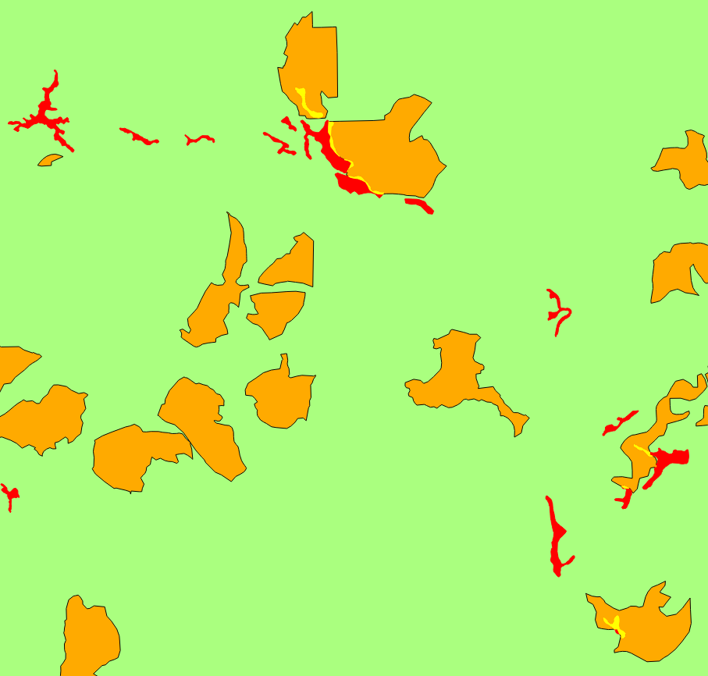

**Figure 6: Areas of Habitat Overlap**

1. **Save** your map.
2. Union

You will now combine both habitat layers in different ways using both the **Union** and **Dissolve** tools. **Union** creates a new GIS layer that combines all the geometries of both input layers. **Dissolve** merges all coincident polygons together.

1. **Open QGIS Desktop 2.2.0** and open Lab 4/Data/Lab 4.qgs if it is not already.
2. From the menu bar, choose **Vector 🡪 Geoprocessing Tools 🡪 Union**. Fill out the **Union** window as in **Figure 7** below.
3. When finished **Click Ok** and then **click Close**.

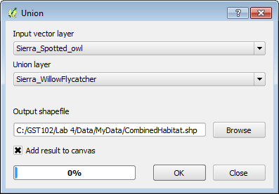

**Figure 7: Union Tool**

1. The output contains all the polygons from both layers (**Figure 8**). In addition, all the polygons retain their original attributes! Overlapping areas receive attributes from the Union layer (**Sierra_WillowFlycatcher).**

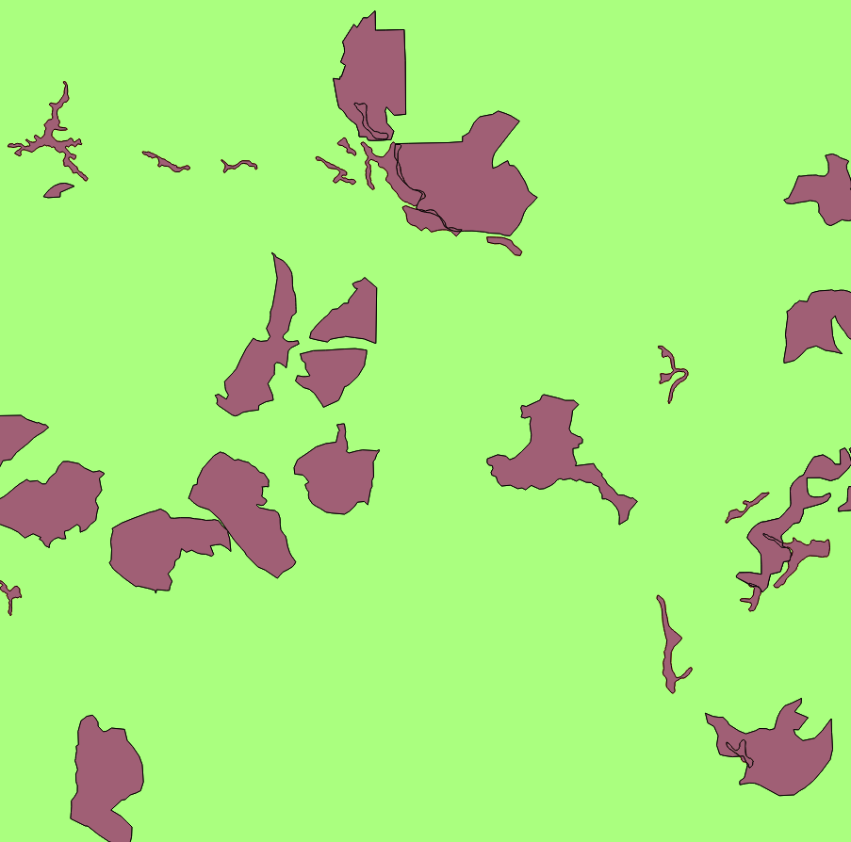

**Figure 8: Union Output**

Now you will **Dissolve** all the polygons into one contiguous polygon layer representing areas of habitat for both species.

1. From the menu bar, choose **Vector 🡪 Geoprocessing Tools 🡪 Dissolve**. Fill out the **Dissolve** window as in **Figure 9** below.
2. When finished **Click Ok** and then **click Close**.

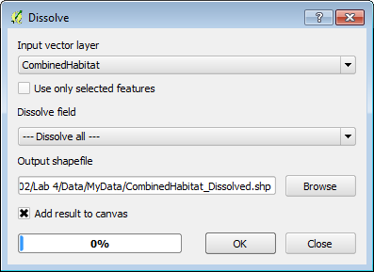

**Figure 9: Dissolve Tool**

1. **Figure 10** shows the **output** of the **Dissolve** operation.

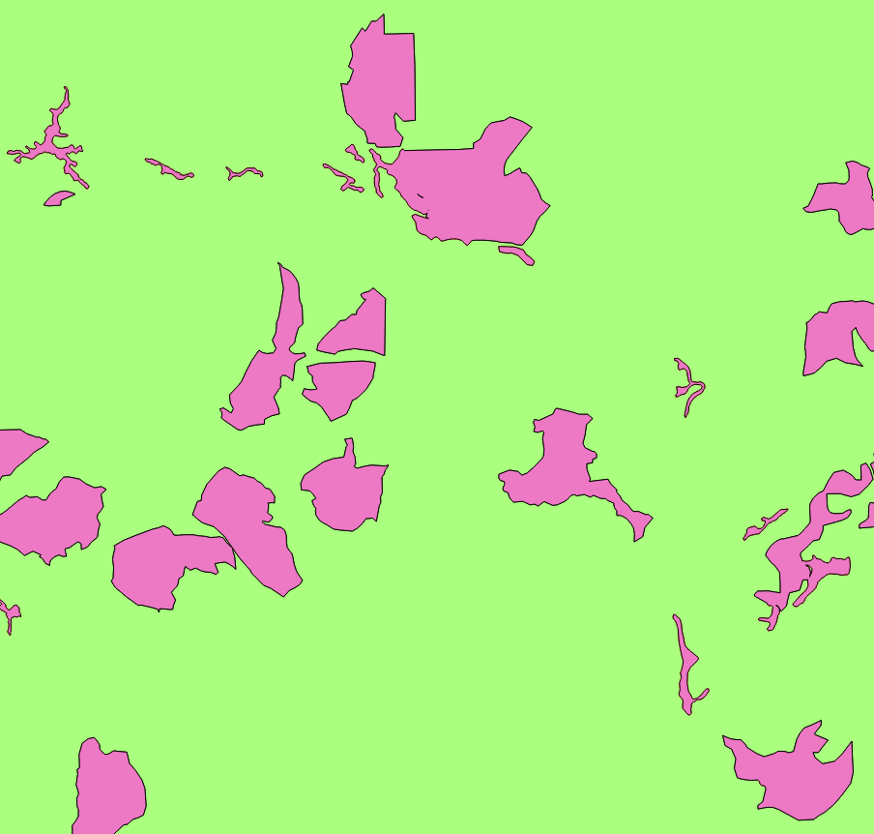

**Figure 10: Dissolve Output**

1. **Save** your map.
2. Join Attributes by Location

In this final task, you will incorporate the Ranger District shapefile into the analysis. There are three Ranger Districts in the Sierra National Forest. You will determine the Ranger District that each spotted owl habitat polygon is situated in. To do this you will conduct a spatial join. Unlike an attribute join done in Lab 3, a spatial join appends attributes from one layer to another based on the location. This will allow you to attach the attributes from the Ranger District layer onto the spotted owl layer.

1. **Open QGIS Desktop 2.2.0** and open Lab 4/Data/Lab 4.qgs if it is not already.
2. **Add** the **Sierra_Ranger_Dist** shapefile to QGIS Desktop.

Remember that data layers need to be in the same coordinate reference system when conducting a geoprocessing operation between layers.

1. **Open** the **Layer Properties** for the Ranger District layer.

**Question # 2 – What is the coordinate reference system of the Ranger District layer?**

1. Since it is in a different coordinate reference system than the other datasets, you will first have to save it to a new coordinate reference system. **Right click** on **Sierra_Ranger_Dist** and choose **Save as…**
2. Fill out the **Save vector layer as…** form as shown in **Figure 11.** You can find the output coordinate reference system by searching on the EPSG code for CA Albers: 3310.

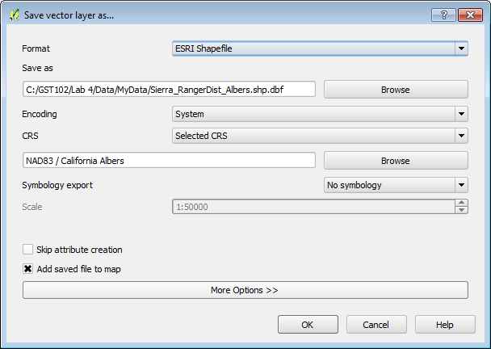

**Figure 11: Save Vector Layer As…**

1. Once the layer has been re-projected, **Remove** the **original Ranger District** layer from QGIS Desktop.
2. **Style** the new **Albers Ranger District layer** with a **Fill** of **No Brush** and a **Border** of dark green (**Figure 12**).

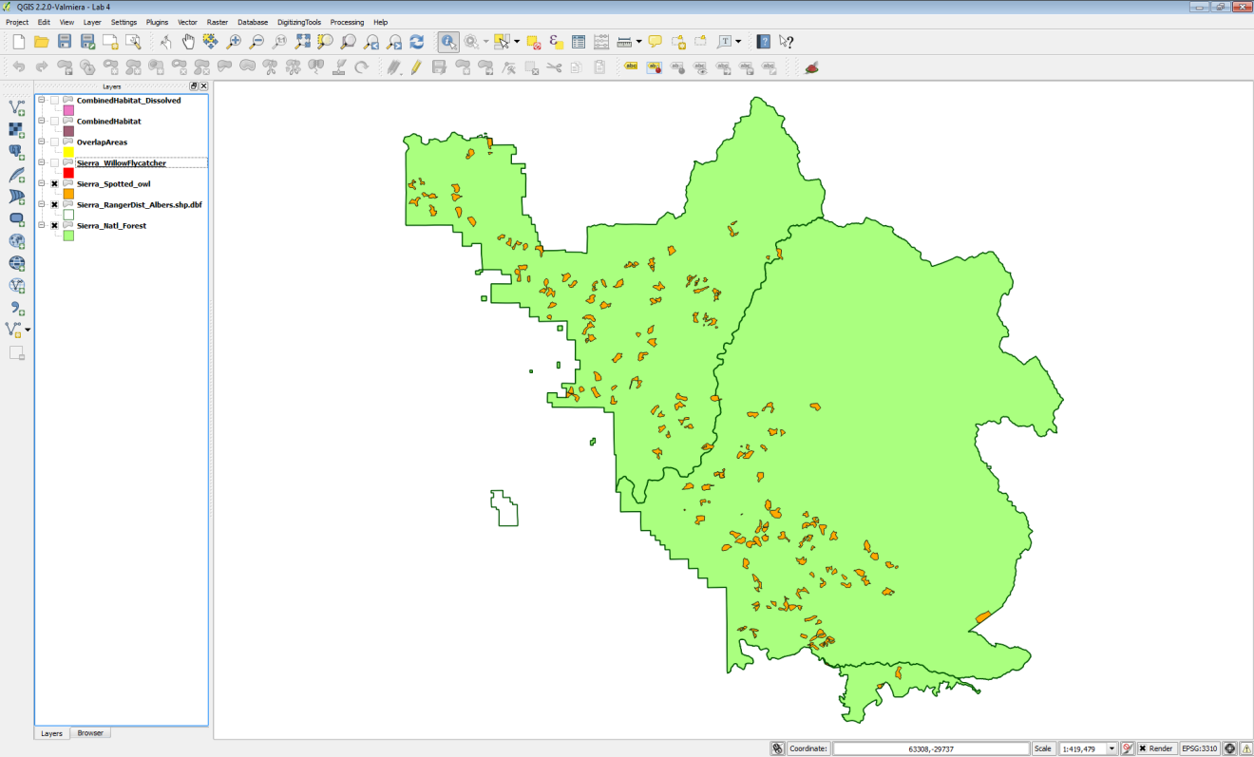

**Figure 12: Albers Ranger Districts Layer Added to Map and Styled**

1. Now you are ready to conduct the spatial join. From the menu bar, choose **Vector 🡪 Data Management 🡪 Join attributes by location**. Fill out the form as in **Figure 13** below. The output will be in the form of a new spotted owl habitat shapefile with Ranger District attributes appended.

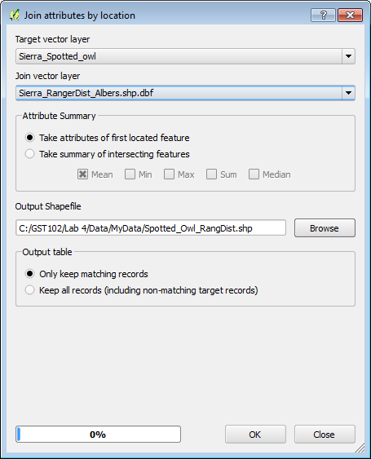

**Figure 13: Spatial Join Tool**

1. **Click OK** to perform the join. When finished confirm that you want the layer added to the map. **Click Close**.
2. Select the **Spotted_Owl_RangDist** layer in the Table of Contents by clicking on it once. Now use the **Identify** tool  to query the individual polygons of the **Spotted_Owl_RangDist** shapefile. You will see the additional Ranger District attribute columns added.
3. **Save** your project.

5 Conclusion

In this lab, you explored the use of vector overlay tools with habitat data in the Sierra National Forest. There are many similar overlay tools, which when used in combination, allow you to parse the spatial relationships of multiple data layers. These tools allow you to extract data and turn it into information by narrowing down the area of interest.

6 Discussion Questions

1. Describe the Clip operation.

2. Describe the Intersect operation.

3. How do Intersect and Clip compare in their output?

4. Before you run an overlay tool, what aspect of your input spatial data layers should you inspect, to ensure it is the same for all?

7 Challenge Assignment

The Southwest willow flycatcher data also covers multiple Ranger Districts. Conduct a spatial join between the Southwest willow flycatcher data and the Ranger districts as you did with spotted owl in Task 4. Compose a map that shows the both the spotted owl and Southwest willow flycatcher data styled by the Ranger District they are situated in.